Ask your partner to choose one of the shapes, and then try to identify which it is.
Your partner can only reply "Yes" or "No" to your questions.

Then swap over.
Who can identify the other's shape with the fewest questions?

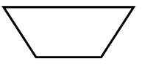 |  | 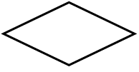 | 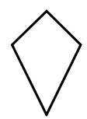
Isosceles trapezium | Rectangle | Rhombus | Kite

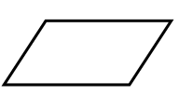 |  | 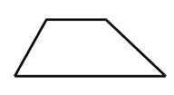 | 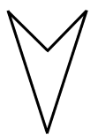
Parallelogram | Square | Trapezium | Arrowhead

How many questions do you need to ask to guarantee you know your partner’s shape?
What would you ask first?
If your friend says "Yes", what would you ask next?
If your friend says "No", what would you ask next?
Charlie says he can always identify Alison's shape after asking just three questions.
Which question might Charlie ask first? Which follow-up questions might he then ask?
Can you invent a game with more shapes, where you can always identify your friend's shape in four questions? What is the maximum number of shapes you could have in such a game?

